Dear Friends,

I can vaguely recall a particular picture book from my childhood. It was the story of a family on a woodland hike. The youngest in the family was a curious little boy who loved to notice every plant and rock, each lichen and creature that marked the family’s path. As you might expect, the rest of the family was often frustrated at having to wait for their youngest member; they were ready to get to their destination and he was holding up their progress! Soon the family realized that they were lost in the woods and with little recollection of how to get home. The boy, however, showed them the way out. He remembered things like the shape of the last tree and the color of the boulder a little way back. He could point out where he’d seen a certain flower or noticed tracks in the mud. Soon the whole family found their way home.

Perhaps you know where this is headed (even if it is an odd thing to share in an Annual Report!): when the one who was thought of as *least* got promoted to first in line, that family found their way home.

There are lots of ways that an Annual Report to the congregation about the year 2020 might begin. It was quite a year, to be sure. One way to remember 2020 is as an experience of how hard it is to let the least be first. It is hard to decide we will not worship in person until the most vulnerable ones are able to join us. Such a choice slows down the rest of the family; it keeps the ones at the front of the line from being able to enjoy their walk. 2020 also reminded us how hard it is to pause our own views about pressing issues or political perspectives in order to hear what others might think or hope or dream. Both ways of putting the least and last first mean practicing more sacrifice and humility than comes naturally to us. Yet, putting the concerns of the least first – in all sorts of ways – has been NRPC’s hallmark choice of 2020.

We embarked upon 2020 as a year to focus on the SERVE part of WORSHIP 🞄 GROW 🞄 SERVE. And until sitting down to write these remarks, I might have said that we didn’t quite get to that focus. We *definitely* served our Presbytery in the best of NRPC style when we hosted the February meeting of the Presbytery. (THANK YOU to the many of you who labored long and hard to birth that beautiful day! See elsewhere in this report for photos of the day we hosted.) And all through 2020 this congregation used untold creativity to find ways to serve one another and our community in spite of all the impediments we encountered; read more about this throughout this annual report. Thank you to *all* who shared energy, intelligence, imagination and love to further our ministries in these unprecedented times; particular thanks to Elders and Deacons who have led so tirelessly.

Ultimately, though, our SERVE focus was most apparent when we did the hard work of first considering the least among us in every challenge we encountered. I hope we will someday look back at 2020 as a time when we found our way home, even in the midst of debilitating trauma. For our home is a kingdom where the formerly last are first and where no one gets left behind. The path home is not an easy way, particularly because it is so very hard to give up the front of the line in order to give preference to someone else. Travelling that hard road in spite of the challenges, though, makes home an ever more grace-filled space and that discovery could be 2020’s gift.

****Thanks for letting me travel alongside you.   
Grace and peace,

***The mission of North Raleigh Presbyterian Church is   
to be a welcoming community serving Jesus Christ through engaged discipleship.***

www.northraleighpc.org 11905 Strickland Road, Raleigh, NC 27613 (919) 848-9529

The theme of the year was marked by creativity, ingenuity, and perseverance to continue to offer opportunities for us all to connect with God and each other despite many ongoing challenges.  
  
The Worship committee would like to thank our dedicated staff for their extra hours and effort to provide worship for our congregation, and we would like to thank our congregation for their patience, understanding and support as we strive to find the balance between safely gathering in accordance to guidelines while ensuring that worship is available for everyone in the same way.  
  
Please continue to pray for us in 2021 that we find this balance that cares for us all.

***Pre-COVID***

* We altered the flow for both the greeters and the welcome table in the Narthex

We had plans (and stay tuned for these to come) to:

* Partner with Fellowship to offer more frequent gatherings after Worship to connect and reflect on the sermon,
* Install a sturdier “closet” for name tags in the Sanctuary to allow more space in the Narthex,
* Place a rocking chair in the Sanctuary for parents with young children who had “the wiggles”.

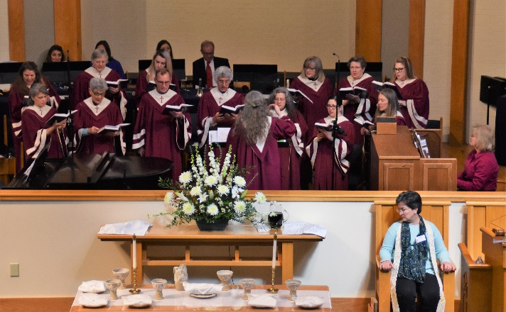

above:

Worship leadership for the Presbytery meeting.

below:

Ted delivers a report during the meeting.

(photos courtesy Derek Maul)

**Vimeo Statistics for 2020:**

* 8,324 views on our channel
* 2,658 unique viewers on our channel
* Over 97 days of total time watched
* We reached 11 countries with our videos
* We created and uploaded 110 videos, including recorded worship services, Sacred Arts and Spiritual Practices, Advent resources, MAX resources, Summer Sunday School series, Hymn Sings, Stations of the Cross, and many more!

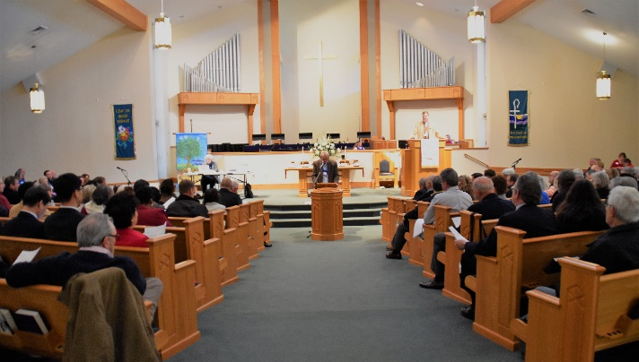

***COVID Response***

* We transitioned Worship services to digital via Vimeo starting in March with the help of staff, volunteers, and a new high school intern.
* We implemented new ways to worship for Easter and Advent by developing an outdoor Christmas pageant, Livestreaming a Christmas Eve service, and creating an Easter video from crosses made at home.
* We offered Drive Thru Communion, outdoor Vesper Services throughout the year, and Deacon Parish meetings as additional ways to worship and gather.
* We developed and implemented a congregational survey to better understand our communication and gather data to help plan for when we can worship in person.
* We initiated Live Streaming in preparation of moving to that technology in 2021.
* We continued to discuss and prayerfully balance the risks of meeting in person with the need to provide worship services for all in the NRPC community.

***Children's Education***

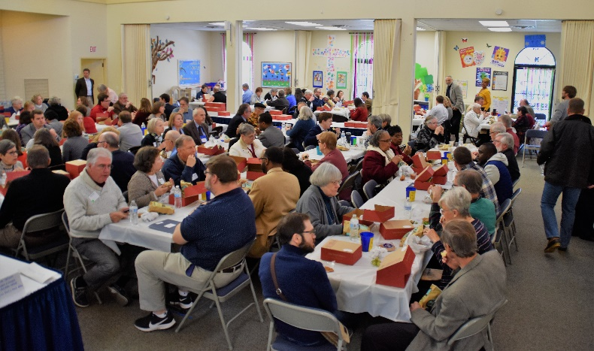

Presbytery lunch was a Fellowship FEAT! NRPC made it look easy.

(photo courtesy Derek Maul)

* Socially Distanced MAX (including Trunk or Treat)
* Check-in Cards to all children/youth

***Youth Education***

* Youth Group (in person and on Zoom).
* Youth Faith and Life Forum
* Youth Christmas Party
* Socially distanced Montreat Youth Conference

***Adult Education***

* Adult Sunday School classes (in person and on Zoom)
* Advent videos
* Summer Sunday School videos
* Parent Chats (on Zoom)
* Advent Wreath Making
* Men's Bible Study on Zoom
* Movie Night monthly on Zoom
* Brunch for College Students

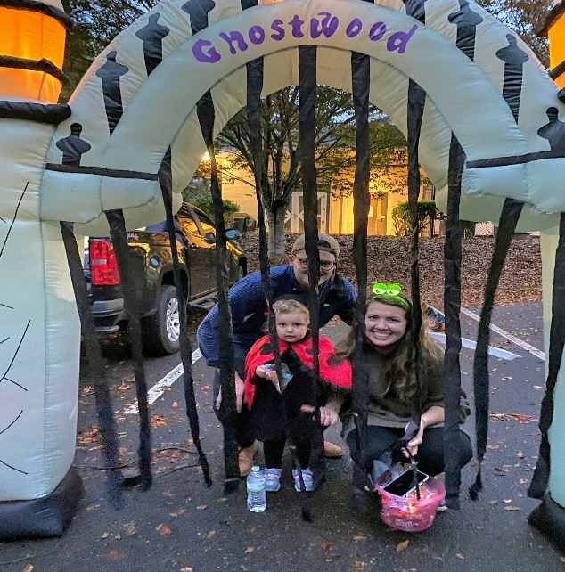

The Meltons at Trunk-or-Treat

***Deacons***

Trunk-or-Treat!

Photos courtesy Roger Askew, Julie Fotheringham, and Debbi Freer

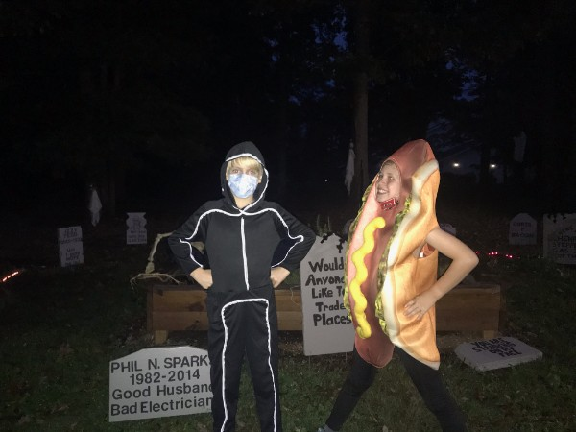

Bennett and Jack!

Congregational care was a challenge in 2020--members of our Board of Deacons found a variety of special ways to stay in touch with the members of their parish. This included flowers, notes and cards, games and activities families could do together, funny and thoughtful emails, and homemade goodies. The diaconate established a meal ministry to help support families in difficult times.

Parish gatherings were held outside in the Fall where members had the opportunity to chat with each other and with Lisa.

As 2021 begins the NRPC Board of Deacons are working diligently to help keep the members of NRPC connected.

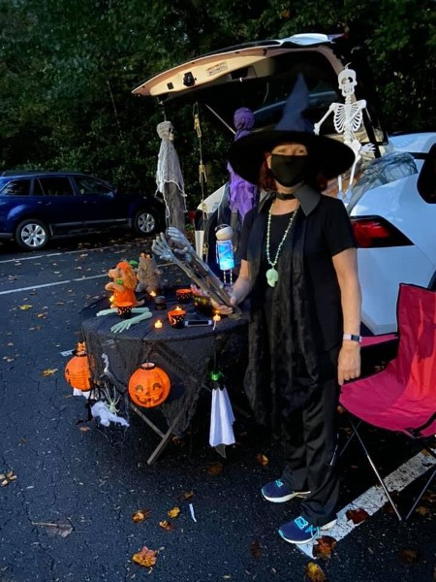

Debbie Freer

***2020 Outreach Committee highlights***

The 2020 Yard Sale raised a little over $16,000. We had a record number of volunteers participate and a great turnout from the community.

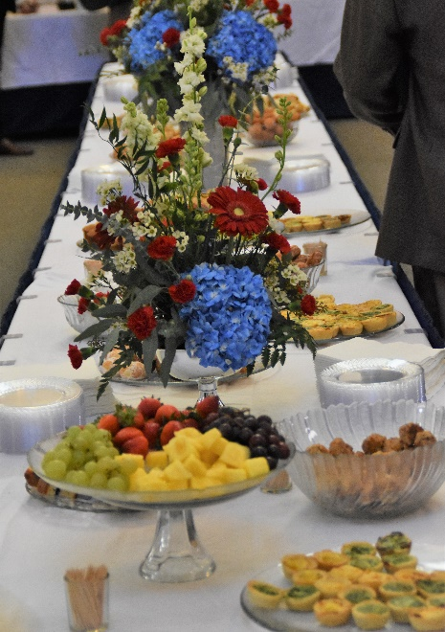

Feeding God’s people is one of NRPC’s obvious spiritual gifts. This was the breakfast spread at the Presbytery meeting last year. We’re equally generous in feeding our community through our outreach.

Photo courtesy Derek Maul

We held collections during 2020 for:

* North Raleigh Ministries (2)
* Socks and Undies for the Women's Center
* Snack Collections for Essential workers at local retirement facilities
* Food and Masks collections for Episcopalian Migrant Farm Workers Ministry
* Snack Collections for UNC Hospital nursing staff on the PICU/NICU
* Back Packs for Wake County Foster Kids
* Angel Tree gifts for Wake County Foster Kids
* One Warm Coat Collection

Along with the regularly budgeted benevolences, Yard Sale proceeds were used to support the following organizations:

* Additional funds to The Food Bank of Central and Eastern NC
* Presbyterian Disaster Assistance (for California Wildfires)
* Purchases of Food Lion gift certificates for staff to hand out to those coming to the office needing assistance
* Additional funds to North Raleigh Ministries (early Covid)
* Feeding The Gulf Coast (hurricane disaster relief)
* A Place At The Table
* Episcopalian Migrant Farm Workers Ministry
* Snacks sent for The Helen Wright Center (early Covid)
* UNC Health Foundation -to provide meals for PICU/NICU families
* Honduras Relief efforts

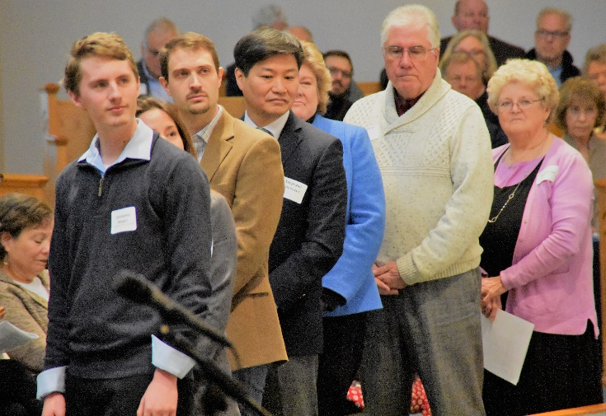

Part of NRPC’s outreach is in the way we serve the broader church.In this photo from the Presbytery meeting, Christopher Morgan is being commissioned as a Young Adult Advisory Delegate to our General Assembly meeting.

Photo courtesy Derek Maul

Other Outreach ministry in 2020:

* Over $1,000 was raised in our NRPC Crop Walk with proceeds going to World Church Organization
* Lap Blankets were donated by church members, then distributed to members living in retirement communities.
* Budgeted funds for the Special Olympics were redirected to Pennies For Hunger.
* MAX outreach supplied 25 hygiene kits for Church World Services

***Faith Ministry Building Renovation***

In 2019, Session requested the formation of a committee to investigate remodeling and updating the FMB kitchen. As the Kitchen Renovation Team met with builders and architects to develop a scope of work, it became apparent that due to the age of the FMB, any structural modifications to the kitchen would create code compliance issues in the building as a whole. Due to the breadth of both jobs, the Kitchen Renovation Team requested Session form a second committee to address updating the FMB to comply with code. Session approved the request but also called for the new committee to address incorporating new office space, better meeting space, and a dedicated entrance/welcome space into the plans. After many meetings by both teams where research of past, present and future use reports were developed and analyzed, a scope of work for both projects was developed. In 2020, NRPC hired EA Studio Architect + Design LLC, to render design plans to renovate the kitchen and the FMB. The goal was to design spaces to better serve our congregation and our community today and into the future. In March 2021, the teams will present the drawings, project specifications and proposed timelines to Session for approval and to develop a timeline for moving the projects forward.

***Communictions & Technology***

* Secured Zoom accounts so staff and members could gather virtually
* Researched methods of livestreaming and purchased equipment
* Implemented the Now@NRPC page on the website to serve as a news source for details and updates

***Buildings & Grounds***

* Replaced defective thermostats in Sanctuary and Narthex
* Volunteers maintained the building and grounds throughout the campus closure
* Replaced the roof on the shed behind the FMB
* Addressed drainage issues between the Sanctuary and FMB
* Held a Campus Spruce Up day in the fall

NRPC’s Security Response Team in action at the Presbytery meeting.

Photo courtesy Derek Maul

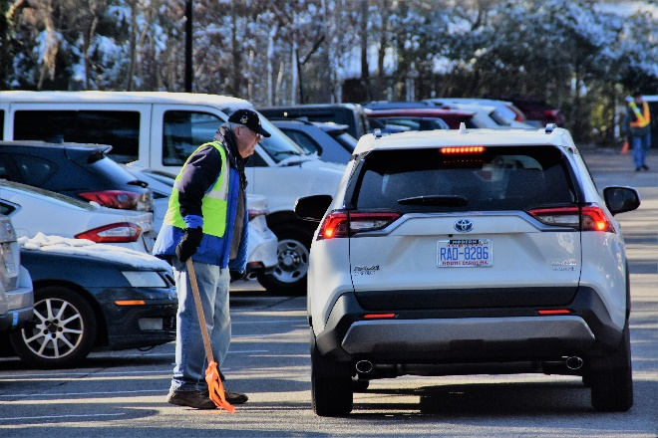

**2020 Membership Summary**

**In the Church Triumphant:** Jacqueline Fleming, Jean Hines, Paul Hitchcock, Jewel Molten

**New Presbyterians (Baptisms):** Jacob Michael Robbins

**New to Our Fellowship:** Peggy and Edward Gleason, Barbara Knowles, Tayler Melton, Steve Voorhees

**Total Membership:** 282  
**Children:** 65 **Affiliates:** 5

**2020 Financial Summary**

*Budget Actual*

Total Income: 424,333 454,055

Total Expense: 446,287 406.551

Income Detail:

Pledges Paid: 366,283 342,652

Other Offerings 55,000 76,883

Other Income 3,050 31,520

Expense Detail:

Benevolence 40,553 47,552

Human Resources 290,984 257,367

Program/Property 114,750 101,631

Program/Property Expense Detail:

Worship 6,725 4,962

Grow 16,675 6,683

Serve (incl. Property) 91,350 89,986

**Stewardship snapshot**: 87 pledges for 2021 (57.6% of households) totaling $328,002

**WORSHIP**

**Worship • Sacred Arts • Spirituality**

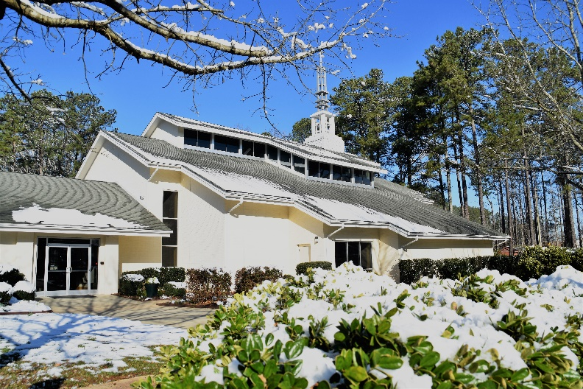

**2021 Session**

**WORSHIP**

Beth Morgan, Worship

Ann Antoun, Sacred Arts and Spirituality

**GROW**

***Education:***

Haley Stallworth, Mary Frances Mabry

***Fellowship:***

John Grovenstein

***Care:***

Under leadership of the Diaconate

**SERVE**

***Outreach:***

Bob Lippard

***Discipleship:***

Matt Bales, Engagement

Candy Tedrick, Stewardship/Engagement

Charmane Dail, Mission & Vision

***Administration:***

John McKinney, Finance

Danny Heater, Building & Grounds,

Megan Livengood, Comm/Tech

Jennifer Worth, Risk Mgmt & Human Res.

Photo courtesy Derek Maul

**Staff**

Lisa Hebacker, Pastor

Ju Huyn Kim, Organist

Brandon Melton, Associate Pastor

Terri Nicotera, Director of Music

Caroline Parker, Office Administrator

**2021 Diaconate**

Janet Livengood, Moderator

TBA, Vice Moderator

Krista Wright, Past Moderator

Rick Bell Pam Homolya

Leigh Anne Carter Tiffany Hook

Will Collins Jen Judy

Karen Fink Janet Livengood

Lori Fisher Rosemary Lunsford

Julie Fotheringham George Snead

Judith Ganey Krista Wright