NRPC NEWS and EVENTS

Birthdays: Sue Fuller, 1/20; Knox Gordon, 1/21/; Marny Jacoby, 1/22; Kim Anderson, 1/24; Vidalia Patterson, 1/25
Associate Pastor Nominating Committee update: The associate pastor nominating committee has been hard at work since being elected this past September. We completed a ministry information form - the essential document for posting an open position in our denomination - and it has been approved and circulated. We have had many meetings since September. We have received and reviewed material from many potential candidates and have contacted several. However, our work is not complete. We thank you for your prayerful support as we continue our work.
Gold Stars for 2019: To deepen our prayer ministry and know one another better, please take a gold star from the Narthex. On one side find the name of church members to pray for this year. Begin by remembering her/him/them in prayer and as the year goes on, reach out and get to know them and learn what to pray for more specifically in order to care for this member of our church family. On the other side of the star, there is a word. Keep this word in your mind as you pray this year. Reflect on how it comes out in your life; consider what God is telling you with this word this year; discover how this word is reflected in your daily study and scripture reading.
NRPC is on Instagram and Facebook: Follow NRPC on Instagram @nraleighpc. On Facebook, NRPC has both a closed group and a public page. Please send a request through Facebook to join the closed group where you will find photos, event updates, and announcements for members and friends of NRPC. The closed group is moderated by an elder; comments and posts about NRPC events and activities are welcome.

Tshirts: NRPC tshirts are available for pick up in the Narthex today after worship.

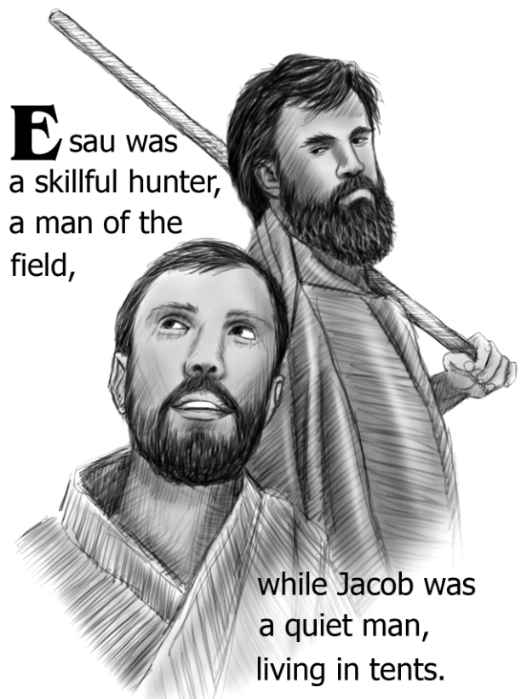
THIS WEEK AT NRPC
Sunday 1/20 | 8:45 AM  9:15 AM-10:15 AM  10:30 AM  4:30 PM  6:00 PM | Youth Bells (S)  Sunday School (F)  Worship (S)  Youth Group (F)  Youth Choir (S)
Monday 1/21 | 6:30 PM  6:30 PM | Fellowship w/ Books (O)  Session Meeting (F)
Tuesday 1/22 | 10:30 AM  1:15 PM  7:00 PM | Tuesday Morning Bible Study (L)  Staff Meeting (A)  Adult Bells (S)
Wednesday 1/23 | 7:00 PM | Adult Choir (S)
Thursday 1/24
Friday 1/25 | 7:15 AM | Men’s Bible Study (L)
Saturday 1/26
Sunday 1/27 | 8:45 AM  9:15 AM-10:15 AM  10:30 AM  4:30 PM  6:00 PM | Youth Bells (S)  Intergenerational Sunday School (S)  Worship (S)  Youth Group (O)  Youth Choir (S)

Locations Legend:
F=Faith Ministries Building  L=Library  A=Admin Office  P=Pastor Office  E=Educator Office | S=Sanctuary; N=Narthex  T1, T2=East Trailer  T3, T4=Southwest Trailer  T5, T6=Northwest Trailer  M=Multiple locations
North Raleigh
Presbyterian Church
Second Sunday after Epiphany
January 20, 2019
11905 Strickland Rd
Raleigh, NC 27613
919-848-9529
northraleighpc.org
We extend a warm welcome to our guests!
We are glad that you are worshipping with us.
Please visit our table in the Narthex that we may extend to you a personal welcome from the people of
North Raleigh Presbyterian Church.
Childcare is available in the nursery
located in the Faith Ministries Building.
Children’s bulletins and Bibles
are located at the back of the sanctuary,
as are hearing assistance devices and large print bulletins.
The mission of North Raleigh Presbyterian Church is to be a
welcoming community serving Jesus Christ through
engaged discipleship.

Ministers: All the Congregation
Pastor: Lisa Hebacker LisaHebacker@nraleighpc.org
Director of CE: Brandon Melton BrandonMelton@nraleighpc.org
Director of Music: Terri Nicotera TerriNicotera@msn.com
Church Organist: Ju Hyun Kim Kimjuhyun81@gmail.com
Office: Caroline Parker Office@nraleighpc.org
We are a congregation of the Presbyterian Church (USA)
CCLI # 2043894

GATHERING
WELCOME AND ANNOUNCEMENTS
Please find the Friendship Pad
and pass it down the pew so all may sign.
PREPARATION FOR WORSHIP Source unknown
Prepare us, O God, for worship and give us grace to serve you with reverence, joy, and thanksgiving; through Jesus Christ our Lord. Amen.
PRELUDE Chime Prelude Reymond Herbek
As the acolyte processes with the light,
we welcome the presence of Jesus Christ, light of the world,
into our worship.
* CALL TO WORSHIP Psalm 13
One: How long, O Lord?
Will you forget me forever?
How long will you hide your face from me?
All: How long shall I have perplexity in my mind,
and grief in my heart, day after day?
How long shall my enemy triumph over me?
One: Look upon me and answer me, O Lord my God;
give light to my eyes, lest I sleep in death;
lest my enemy say, "I have prevailed,"
and my foes rejoice that I have fallen.
All: But I put my trust in your mercy;
my heart is joyful because of your saving help.
One: I will sing to you, O Lord,
for you have dealt with me richly;
All: I will praise the name of the Lord Most High.
* HYMN 619 Praise, My Soul, the God of Heaven
* PRAYER OF CONFESSION Vienna Cobb Anderson
Following the Call to Confession
please observe a moment of silent confession.
We are a broken, divided family of lonely individuals, each alone; truly, we’re not a family. Communication with each other seems impossible, and love vanishes into the void. Yet both are what we desperately need. We all need and want each other. Yet we’re too proud to admit it, too proud to confess that we’re each to blame for our separation, loneliness, and pain. We add brick upon brick to the wall that divides and isolates us.
You alone are our hope, O God. Your love breaks down walls that isolate and divide us. Your love heals, forgives, and makes us whole again. Restore us and reconcile us, that we may be a family, and live. Amen.
* DECLARATION OF GOOD NEWS
One: Friends, in the name of Jesus Christ,
we are loved and accepted, forgiven and freed!
All: Thanks be to God.
*THE PEACE
One: The peace of Christ be with you.
All: And also with you!
One: Please share the peace of Christ with your neighbors.
*RESPONSE OF PRAISE 305 v.4 Come Sing, O Church, in Joy!
Come sing, O church, in joy! Come join, O church, in song!
For Christ the Lord has triumphed o’er the ages long!
In bold accord, come celebrate the journey now and praise the Lord!
PROCLAIMING
NEW TESTAMENT LESSON 2 Corinthians 5:12-21
ANTHEM One Song Pepper Choplin
OLD TESTAMENT LESSON Genesis 33:1-11
SHARING THE FAITH WITH THE YOUNGER CHURCH
Preschool-1st grade may remain in worship or attend Children’s Church.
SERMON Reconciliation
*HYMN 774 There Is Now a New Creation
ResponDING
*AFFIRMATION OF FAITH A Declaration of Faith
The Spirit brings us out of death into life, out of separation into fellowship. The Spirit makes us aware of our sinfulness and need, moves us to abandon our old way of life, persuades us to trust in Christ and adopt his way. In all these things we are responsible for our decisions. But after we have trusted and repented we recognize that the Spirit enables us to hear and act. It is not our faith but God's grace in Jesus Christ that justifies us and reconciles us to God. Yet it is only by faith that we accept God's grace and live by it.

PRAYERS OF THE PEOPLE AND THE LORD’S PRAYER
Our Father who art in heaven, hallowed be thy name. Thy kingdom come, thy will be done, on earth as it is in heaven. Give us this day our daily bread; and forgive us our debts, as we forgive our debtors; and lead us not into temptation, but deliver us from evil. For thine is the kingdom and the power and the glory, forever. Amen.
INVITATION TO DISCIPLESHIP
PRESENTATION OF TITHES AND OFFERINGS
Offertory All Nature Sings! arr. Lani Smith
* DOXOLOGY 607
Praise God, from whom all blessings flow;
praise Christ all people here below;
praise Holy Spirit evermore;
praise Triune God, whom we adore. Amen.
*PRAYER OF DEDICATION
SENDING
*HYMN 761 Called as Partners in Christ’s Service
*CHARGE AND BENEDICTION
*CHORAL RESPONSE
POSTLUDE Prelude in F Major JS Bach
As the acolyte recesses with the light,
we affirm that Jesus Christ,
the light of the world, leads us out for discipleship.
CHIMING OF THE TRINITY

The rose in the Chancel is in thanks for the birth of Bob and Suzy Lippard’s granddaughter. Parents are Brittany Lippard and Chris Fusting.

*All who are able, please stand.
Please silence all electronic devices.

Leading and supporting worship today:
Preacher: Lisa Hebacker Liturgists: Brandon Melton, Judy Dove
Usher Captain: David Sharer Director of Music: Terri Nicotera
Acolyte: Stella Stallworth Organist: Ju Hyun Kim
Sound Technician: Chuck Nicotera Elder in Charge: Ann Antoun
Chancel Guild: Diana Minor Prayer Deacon: Janet Livengood
Children’s Church: Krista Allen, Riley Morgan Greeters: Ron & Marva Mehaffey

