Leading and supporting worship today:
Preacher: Lisa Hebacker Liturgists: Brandon Melton, Karen Fink
Usher Captain: David Sharer Director of Music: Terri Nicotera
Acolyte: Max Karnatz Organist: Ju Hyun Kim
Sound Technician: John Patterson Elder in Charge: Gina Antoun
Chancel Guild: Diana Minor Prayer Deacon: Bob Lippard
Advent Wreath: The Antoun Family Children’s Church: Tiffany Hook, Janie Chamberlin
*All who are able, please stand.
Please silence all electronic devices.

NRPC NEWS and EVENTS
Anniversaries: Dale & Marny Jacoby, 12/17; George & Sandra Dail, 12/19
Birthdays: Anna Hayes, 12/17; Carol Nicholas, 12/18; Matthew Bales, 12/19; Christina Durstein, 12/22
Thank You to everyone who contributed to the gifts for the Wake County children in foster care! We delivered more than 70 gifts to the children who had a holiday party on December 13. They will open their gifts on Christmas or another day their foster family celebrates.
Rescheduled NRPC Advent celebration is tonight in the sanctuary with the Christmas Pageant and beautiful music from the NRPC Orchestra. Immediately following, dinner will be served by the Men of NRPC in the Faith Ministries Building followed by the Pie Auction.

Christmas Eve Services Join us at 5:00pm for a family friendly service or at 9:00pm for the Service of Nine Lessons and Carols with communion.
TShirt Sales We will be taking orders for new NRPC tshirts every Sunday during December. Short Sleeve shirts will be $10 and Long Sleeve tshirts are $14.00. Add $2 for XXL. Stop by our table and place your order! Shirts will be ready in January.
End of Year Giving Please note that all year end contributions must be received in the Church Office by 5:00 PM on December 31, 2018 or postmarked by December 31, 2018 to be claimed as a 2018 donation.
Epiphany Service will be held on Sunday, January 6 at 5:30pm. "Epiphany" means manifestation or revelation and on Epiphany we will celebrate God's grace made manifest to all the nations of the world. Our celebration will be shaped by an improvisational pageant of the magi's visit to the Christ child. Light-bearers of all ages are invited to gather for Epiphany Vespers in the Sanctuary at the beginning of the service.

THIS WEEK AT NRPC
Sunday 12/16 | 9:15 AM-10:15 AM  10:30 AM  4:30 PM | Sunday School (M)  Worship (S)  Christmas Program (S)  Advent Dinner (F)
Monday 12/17 | 6:30 PM | Session Meeting (F)
Tuesday 12/18 | 1:15 PM | Staff Meeting (A)
Wednesday 12/19 | 6:00 PM  7:00 PM | Advent Bible Study (F)  Adult Choir (S)
Thursday 12/20
Friday 12/21 | 7:15 AM  6:00 PM | Men’s Bible Study (L)  Youth Christmas Party (O)
Saturday 12/22
Sunday 12/23 | 9:15 AM-10:15 AM  10:30 AM | Intergenerational Sunday School (F)  Worship (S)

Locations Legend:
F=Faith Ministries Building  L=Library  A=Admin Office  P=Pastor Office  E=Educator Office | S=Sanctuary; N=Narthex  T1, T2=East Trailer  T3, T4=Southwest Trailer  T5, T6=Northwest Trailer  M=Multiple locations
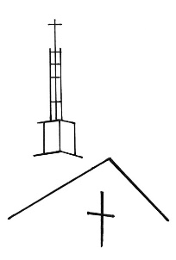
Ministers: All the Congregation
Pastor: Lisa Hebacker LisaHebacker@nraleighpc.org
Director of CE: Brandon Melton BrandonMelton@nraleighpc.org
Director of Music: Terri Nicotera TerriNicotera@msn.com
Church Organist: Ju Hyun Kim Kimjuhyun81@gmail.com
Office: Caroline Parker Office@nraleighpc.org

We are a congregation of the Presbyterian Church (USA)
CCLI # 2043894
North Raleigh
Presbyterian Church
Third Sunday of Advent
December 16, 2018
11905 Strickland Rd
Raleigh, NC 27613
919-848-9529
northraleighpc.org
We extend a warm welcome to our guests!
We are glad that you are worshipping with us.
Please visit our table in the Narthex that we may extend to you a personal welcome from the people of
North Raleigh Presbyterian Church.
Childcare is available in the nursery
located in the Faith Ministries Building.
Children’s bulletins and Bibles
are located at the back of the sanctuary,
as are hearing assistance devices and large print bulletins.
The mission of North Raleigh Presbyterian Church is to be a
welcoming community serving Jesus Christ through
engaged discipleship.

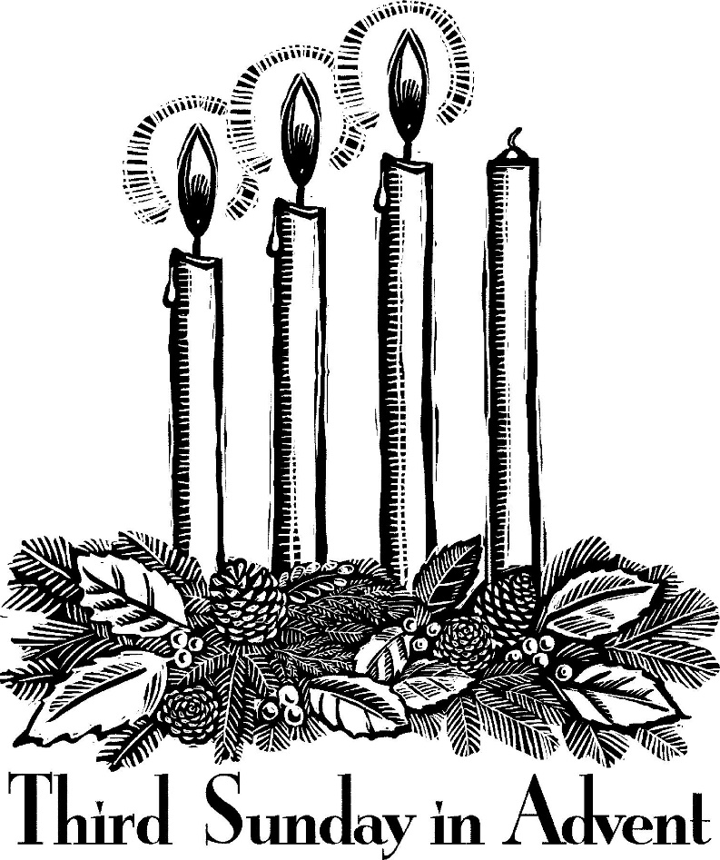

uui

GATHERING
WELCOME AND ANNOUNCEMENTS
Please find the Friendship Pad
and pass it down the pew so all may sign.
PREPARATION FOR WORSHIP adapted by Frances Brienen
God of promise, we live in a wilderness of strident voices and deafening silence, a world of cruelty and malice. As we wait for the land of promise, teach us the ways of new living, lead us to where we hear your word most clearly, renew us and clear out the wastelands of our lives, prepare us for life in the awareness of Christ’s coming, when the desert will sing and the wilderness will blossom as the rose. Amen.
PRELUDE Advent Joy Brian Childers
Adult Bells
As the acolyte processes with the light,
we welcome the presence of Jesus Christ, light of the world,
into our worship.
CALL TO WORSHIP AND LIGHTING OF THE ADVENT WREATH
One: We gather because we are waiting.
All: We are waiting for the coming of Christ anew.
One: We work because we are waiting.
All: We are waiting for a world of love and justice.
One: With all the faithful of every time and place
we bear witness to the light of Christ:
All: With Zechariah, whose tongue was loosened in praise,
we sing a song of blessing, for the God of Israel has visited us and brought our liberation near.
With John the Baptist, calling from the wilderness,
we cry, “Prepare the way of the Lord!
Repent, for the kingdom of heaven has come near.”
One: We light this candle as a sign of the promise that God is always with us.
One: We light this candle as a sign of the promise that God has delivered us from fear.
One: We light this candle as a sign of the promise of baptism in the Holy Spirit.
All: Thanks be to God!
One: We worship because we are waiting.
All: We are waiting for God, whose glory is about to be revealed.
One: Let us worship God!
*HYMN 82 Come, Thou Long-Expected Jesus
*PRAYER OF CONFESSION
Following the Call to Confession
please observe a moment of silent confession.
O Lord, you have blessed us and looked favorably upon us. Forgive us when we live as if we are not redeemed. Move us to trust in you, our mighty savior. O Lord, you have shown us mercy and remembered your covenant. Forgive us when we are merciless and faithless. Move us to serve you without fear, in holiness and righteousness. Have mercy on us, O God. By your grace, forgive us our sins. By your light, deliver us from darkness. By your Holy Spirit, guide us in the way of peace. Amen.
*DECLARATION OF GOOD NEWS
One: Friends, in the name of Jesus Christ,
we are loved and accepted, forgiven and freed!
All: Thanks be to God.
*THE PEACE
One: The peace of Christ be with you.
All: And also with you!
One: Please share the peace of Christ with your neighbors.
*RESPONSE OF PRAISE 113 Angels We Have Heard on High (refrain only)
Glo-ria in excelsis Deo!
Glo-ria in excelsis Deo!
PROCLAIMING
ADVENT II GOSPEL LESSON Luke 1:68-79
HYMN 109 Blest Be the God of Israel
SHARING THE FAITH WITH THE YOUNGER CHURCH
Preschool-1st grade may remain in worship or attend Children’s Church.
ANTHEM An Advent Acclamation Stacy Nordmeyer
Adult Choir and Bells
ADVENT III GOSPEL LESSON Luke 3:7-18
SERMON One More Powerful
*HYMN 163 Wild and Lone the Prophet’s Voice

ResponDING
*AFFIRMATION OF FAITH Adapted from the Study Catechism q.105
One: What do we mean when we pray, "For the kingdom, the power and the glory are yours now and forever"?
All: We give God thanks and praise for the kingdom more powerful than all enemies, for the power perfected in the weakness of love, and for the glory that includes our well-being and that of the whole creation, both now and to all eternity.
PRAYERS OF THE PEOPLE AND THE LORD’S PRAYER
Our Father who art in heaven, hallowed be thy name. Thy kingdom come, thy will be done, on earth as it is in heaven. Give us this day our daily bread; and forgive us our debts, as we forgive our debtors; and lead us not into temptation, but deliver us from evil. For thine is the kingdom and the power and the glory, forever. Amen.
INVITATION TO DISCIPLESHIP
PRESENTATION OF TITHES AND OFFERINGS
Offertory Comfort, Comfort Now My People Paul Manz
*DOXOLOGY
Laud and honor to the Father; Laud and honor to the Son;
Laud and honor to the Spirit; Ever three and ever One.
One in might and one in glory, while unending ages run.
*PRAYER OF DEDICATION
SENDING
*HYMN 106 Prepare the Way, O Zion
*CHARGE AND BENEDICTION
*CHORAL RESPONSE
POSTLUDE Awake, the Voice is Calling Us arr. Paul Manz
As the acolyte recesses with the light,
we affirm that Jesus Christ,
the light of the world, leads us out for discipleship.
CHIMING OF THE TRINITY

